**LEBANESE AMERICAN UNIVERSITY**

**USAID – HIGHER EDUCATION SCHOLARSHIP PROGRAM**

**HES - Volunteering Program Verification Form**

This form is to be used to document volunteering hours. If a student volunteers for multiple organizations, a separate form must be used for each organization. **This form must be turned in by the 28th of each month, the latest.**

I certify that the scholar Nadia Mohamad Abou Hussein completed a total of 10 hours of service at InnovaThrive.

The hours were completed hours as per the below:

Hours # 0 (date) _2/12 – 6/12_ (initials of supervisor) __A.K.___

Hours # 0 (date) _9/12 – 13/12_ (initials of supervisor) __A.K.___

Hours # 0 date) _16/12 – 20/12 (initials of supervisor) __A.K.___

Hours # 10 date) _23/12 - 27/12 (initials of supervisor) __A.K.___

Brief description of the activities the scholar performed or participated in:

I did 2 researches about AI  
1. AI in Predicting Infrastructure Failures  
2. AI in Cultural Heritage Restoration

Written feedback about the scholar’s performance:

Nadia displayed strong versatility and technical expertise through her research on AI in predicting infrastructure failures and cultural heritage restoration. Her research reflects a deep understanding of AI's diverse applications.

Please rate the overall performance of the scholar at your organization:

|  |  |  |  |
| --- | --- | --- | --- |
|  | Mastery (5) | Proficient (3) | Emerging (1) |
| **Problem solver** | X |  |  |
| **Engaged & Committed** | X |  |  |
| **Open-minded & multicultural** | X |  |  |

Signature

& stamp

__________________________

_

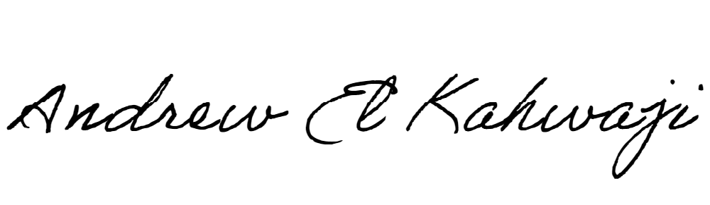

Printed Name _Andrew El Kahwaji_

Date __26/12/2024___

Email __andrew.lifesculptor.coo@gmail.com __

Phone __+961 71 914 378__